Assignment 8
25114035
Garv

1.Write a program to find the majority element in an array (an element that appears more than n/ 2 times, where n is the size of the array).
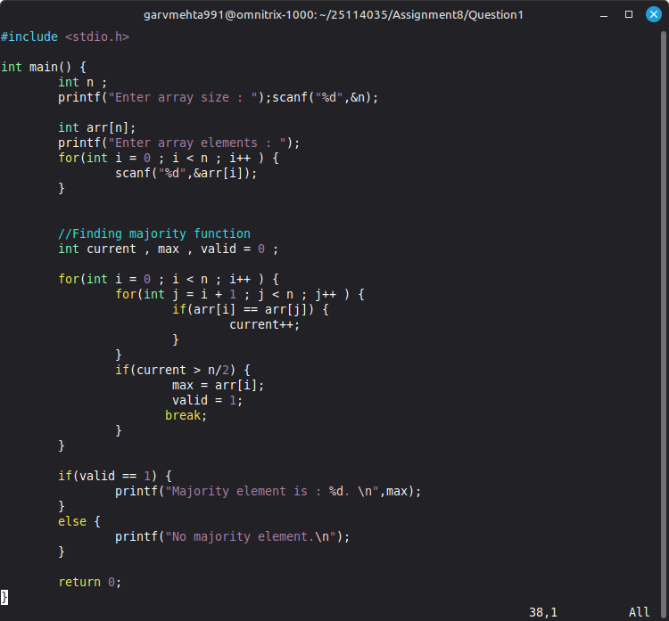

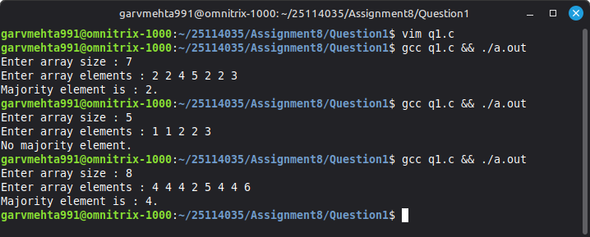

2.Take an integer input n. Write a program in C to print all prime numbers less than n. You may use any efficient algorithm for prime number generation.

